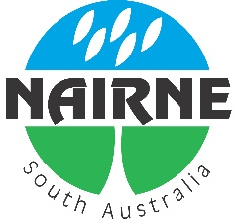
Nairne and Districts Residents Association.

NDRA Interested Persons Contact List
for Residents of the 5252 Postcode Area.

Name: .......................................................................................................

Postal Address: ......................................................................................................................

Residential Address: ..............................................................................................................

Phone (Home): ................................................Phone (Mobile): ..............................................

Email: .....................................................................................................................................

Yes/No: Please add me to the NDRA Interested Persons Email List for NDRA Information and Local Information which NDRA is made aware of.

Please complete this form and either email to – secretary@ndra5252.onmicrosoft.com.au
Or Post to:
Nairne and Districts Residents Association
PO Box 416,
NAIRNE, S.A. 5252

